**Spike- UKCOMDFOB-888-TestDataApproach**

**Test Data creation approach-**

**Sample json Taken-**

{

"name" : "Raphaël",

"phone_number" : "(+91) 983 893 3937",

"website" : "http://google.com",

"language" : "French",

"location" : {

"lat" : -38.383494,

"lng" : 33.427362

},

"address" : "29, side layout, cohen 09",

"types" : [ "shoe park", "shop" ],

"accuracy" : 50

}

**Steps to create the data-**

1. **Serialize the JSON request using Getter and Setters**

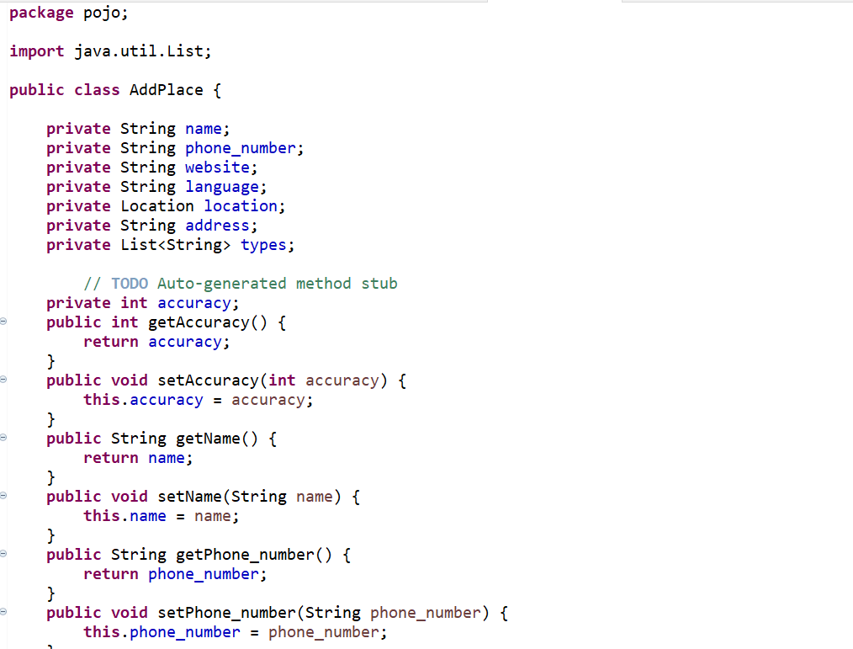

**public** String getWebsite() {

**return** website;

}

**public** **void** setWebsite(String website) {

**this**.website = website;

}

**public** String getLanguage() {

**return** language;

}

**public** **void** setLanguage(String language) {

**this**.language = language;

}

**public** Location getLocation() {

**return** location;

}

**public** **void** setLocation(Location location) {

**this**.location = location;

}

**public** String getAddress() {

**return** address;

}

**public** **void** setAddress(String address) {

**this**.address = address;

}

**public** List<String> getTypes() {

**return** types;

}

**public** **void** setTypes(List<String> types) {

**this**.types = types;

}

}

1. Create a separate class for nested Json and change the return type in the above code

**package** pojo;

**public** **class** Location {

**private** **double** lat;

**public** **double** getLat() {

**return** lat;

}

**public** **void** setLat(**double** lat) {

**this**.lat = lat;

}

**public** **double** getLng() {

**return** lng;

}

**public** **void** setLng(**double** lng) {

**this**.lng = lng;

}

**private** **double** lng;

}

**Step3- Create a feature file**

**\*In the @Given segment we can add the variables for which the values are dynamic and we can assign the values using the example keyword. While Running it will create a separate json for each of the records. In this case it will create seven records.**

**\*In the @When segment we can keep the static value Parameters.**

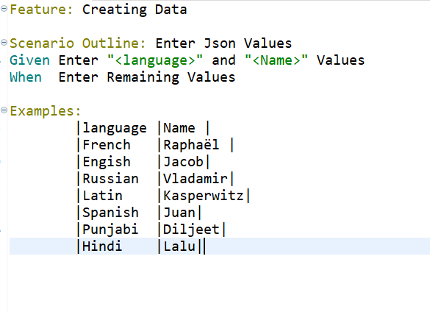

**Step4- Create the test runner file**

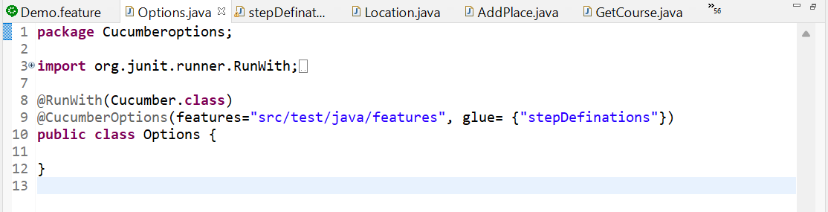

**Step5- Create a StepDefination in accordance.**

**\*In the @Given segment it will pick up the values from the examples keyword in the feature file for Dynamic fields.**

**\*In the @When segment we can set up the values for our static fields.**

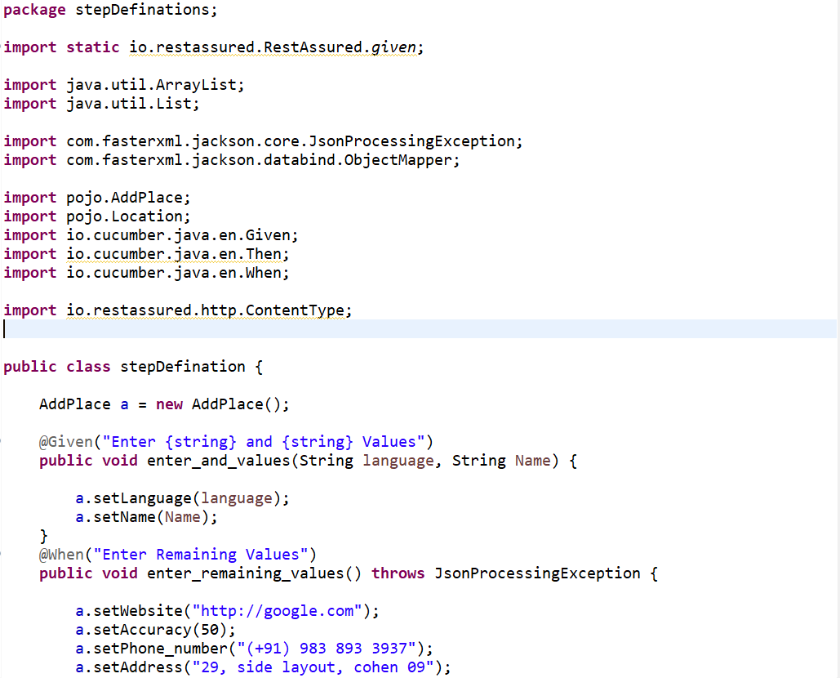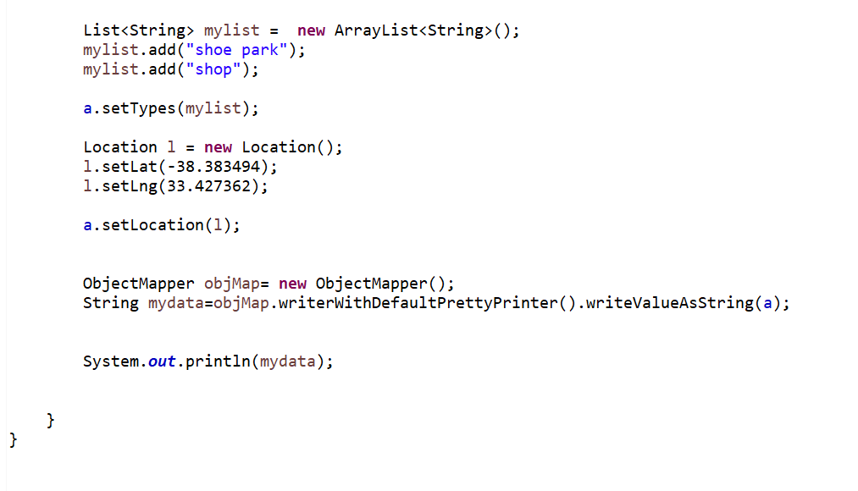

**Run the Runner Class and get the output-**

**Output-**

{

"name" : "Raphaël",

"phone_number" : "(+91) 983 893 3937",

"website" : "http://google.com",

"language" : "French",

"location" : {

"lat" : -38.383494,

"lng" : 33.427362

},

"address" : "29, side layout, cohen 09",

"types" : [ "shoe park", "shop" ],

"accuracy" : 50

}

{

"name" : "Jacob",

"phone_number" : "(+91) 983 893 3937",

"website" : "http://google.com",

"language" : "Engish",

"location" : {

"lat" : -38.383494,

"lng" : 33.427362

},

"address" : "29, side layout, cohen 09",

"types" : [ "shoe park", "shop" ],

"accuracy" : 50

}

{

"name" : "Vladamir",

"phone_number" : "(+91) 983 893 3937",

"website" : "http://google.com",

"language" : "Russian",

"location" : {

"lat" : -38.383494,

"lng" : 33.427362

},

"address" : "29, side layout, cohen 09",

"types" : [ "shoe park", "shop" ],

"accuracy" : 50

}

{

"name" : "Kasperwitz",

"phone_number" : "(+91) 983 893 3937",

"website" : "http://google.com",

"language" : "Latin",

"location" : {

"lat" : -38.383494,

"lng" : 33.427362

},

"address" : "29, side layout, cohen 09",

"types" : [ "shoe park", "shop" ],

"accuracy" : 50

}

{

"name" : "Juan",

"phone_number" : "(+91) 983 893 3937",

"website" : "http://google.com",

"language" : "Spanish",

"location" : {

"lat" : -38.383494,

"lng" : 33.427362

},

"address" : "29, side layout, cohen 09",

"types" : [ "shoe park", "shop" ],

"accuracy" : 50

}

{

"name" : "Diljeet",

"phone_number" : "(+91) 983 893 3937",

"website" : "http://google.com",

"language" : "Punjabi",

"location" : {

"lat" : -38.383494,

"lng" : 33.427362

},

"address" : "29, side layout, cohen 09",

"types" : [ "shoe park", "shop" ],

"accuracy" : 50

}

{

"name" : "Lalu",

"phone_number" : "(+91) 983 893 3937",

"website" : "http://google.com",

"language" : "Hindi",

"location" : {

"lat" : -38.383494,

"lng" : 33.427362

},

"address" : "29, side layout, cohen 09",

"types" : [ "shoe park", "shop" ],

"accuracy" : 50

}